

# **YOUR TITLE**

**FALL DEDUCTION SMS ALERT AND SOUND ALERT**

A MINI PROJECT

REPORT

*Submitted by*

**NAME OF THE STUDENTS**

S.V.PAVAN KUMAR – 1NH18EE744

SHAWIN KRISHNA – 1NH18EE740

SHAIK MOHAMMED ADIL – 1NH18EE745

*In partial fulfilment for the award of the degree of*

BACHELOR OF ENGINEERING

IN

ELECTRICAL AND ELECTRONICS ENGINEERING



**Bonafide Certificate**

This is to Bonafide that the mini project report entitled “**FALL REDUCTION SMS ALERT AND SOUND ALERT**” submitted by **S.V.PAVAN KUMAR,SHAWIN KRISHNA,S.MD.ADIL**, Department of Electrical Engineering, New Horizon College of Engineering, Bangalore in partial fulfilment for the award of the degreeof Bachelor of Engineering , is a record of bonafide work carried out by him/her under my supervision, as per the NHCE code of academic and research ethics.

The contents of this report have not been submitted and will not be submitted either in part or in full, for the award of any other degree or diploma in this institute or any other institute or university. The project report fulfils the requirements and regulations of the institution and in my opinion meets the necessary standards for submission.

|  |  |
| --- | --- |
| Guide Name:- Dr.MUNIPRAKESH  Guide | Dr. S. Ramkumar  HoD |

**Abstract**

Since falls are a major public health problem among older people, the number of systems aimed at detecting them has increased dramatically over recent years. This work presents an extensive literature review of fall detection systems, including comparisons among various kinds of studies. It aims to serve as a reference for both clinicians and biomedical engineers planning or conducting field investigations. Challenges, issues and trends in fall detection have been identified after the reviewing work. The number of studies using context-aware techniques is still increasing but there is a new trend towards the integration of fall detection into smartphones as well as the use of machine learning methods in the detection algorithm. We have also identified challenges regarding performance under real-life conditions, usability, and user acceptance as well as issues related to power consumption, real-time operations, sensing limitations, privacy and record of real-life falls.



**Acknowledgement**

With immense pleasure and deep sense of gratitude, I wish to express my sincere thanks to my supervisor **Dr.MUNIPRAKESH**, Professor, Department of Electrical Engineering, New Horizon College of Engineering, without her/his motivation and continuous encouragement, this mini project would not have been successfully completed.

I am grateful to the Chairman of New Horizon Educational Institution, **Dr. Mohan Manghnani** for motivating me to carry out research in the NHCE and for providing me with infrastructural facilities and many other resources needed for my project work.

I express my sincere thanks to **Dr. S. Ramkumar** HoD, Department of Electrical Engineering, New Horizon College of Engineering for his kind words of support and encouragement.

I wish to extend my profound sense of gratitude to my parents for all the sacrifices they made during my project and providing me with moral support and encouragement whenever required.

Date:

Place:BANGALORE

OUR NAME(s)

S.V.PAVAN KUMAR

SHAWIN KRISHNA

S.MD.ADIL

**Table of Contents**

|  |  |  |
| --- | --- | --- |
| **Chapter no:-** | **Contents** | **Page no.** |
| 1) | **INTRODUCTION** (1.1Objective, 1.2main content) | 7-8 |
| 2) | **Hardware description** (2.1Circuit diagram, 2.2Components, Componts description) | 9-17 |
| 3) | **Hardware implementation** (3.1working of project, 3.2System design, 3.3Applications) | 18-21 |
| 4) | **Block diagram** | 22 |
| 5) | (**5.1Hardware picture, 5.2Theory)** | 23-24 |
| 6) | **Result** | 25 |
| 7) | **(7.1 Advantages,**  **7.2 Disadvantages, 7.3 Conclusion)** | 26 |
| 8) | **Reference** | 27 |

**LIST OF FIGURES**

|  |  |  |  |
| --- | --- | --- | --- |
| **S.no** | **Images** | | **Page no** |
| 1 | Circuit diagram | 9 | | |
| 2 | Accelerometer adxl 335 | 10 | | |
| 3 | Sim 300 gprs model | 11 | | |
| 4 | Antenna | 12 | | |
| 5 | ATmega8 microcontroller | 13 | | |
| 6 | Male and Female bug strip | 14 | | |
| 7 | 7805 Regulator | 14 | | |
| 8 | Capacitor 100µF/16V | 16 | | |
| 9 | 16MHz Crystal | 16 | | |
| 10 | Resistors | 17 | | |
| 11 | 12v Rechargeable battery | 17 | | |
| 12 | System design | 20 | | |
| 13 | Block diagram | 22 | | |
| 14 | Hardware picture | 23 | | |

**CHAPTER-1**

**Introduction**

**1.1 Overview**

According to the planet health organization approximately 28-35% of individuals aged 65 and over fall annually increasing to 32-42%for those over 70 years aged . The frequency of falls increases with age-related biological changes, which is leading to a highincidence of falls and fall related injuries in the ageing societies. If preventive measures are not taken in the immediate future, the number ofinjuries caused by falls is projected to be 100% higher in 2030. during this context, assistive devices that would help to alleviate this major ill health are a social necessity. Indeed, fall detectors are being actively investigated.

**1.2 Main content**

A fall detection system are often defined as an assistive device whose main objective is to alert when a fall event has ordered. In a real-life scenario, they have the potential to mitigate some of the adverse consequences of a fall. Specifically, fall detectors have an immediate impact on the reduction within the fear of falling and therefore the rapid provision of assistance after a fall. In fact, falls and fear of falling depend upon one another a private who falls may subsequentlydevelop fear of falling and, the other way around ,the fear of falling may increase the risk of suffering from a fall. Fear of falling has beenshown to be related to negative consequences like avoidance of activities, less physical activity, falling, depression, decreased social contact and lower quality of life. They conducted a study with a community alarm users who had experienced a fall within the previous sixmonths. At the end of the study, those who wore the autumn detector appropriately reported that they felt more confident and independent, and thought of that the detector improved their safety. One of the conclusions of the study was that the fear of falling is probably going to be substantially suffering from user perception of the reliability and accuracy of the fall detector.

The other important aspect that fall detectors may help to scale back is that the time the elderly remain lying on the ground after falling (long lie). This time is one of the key factors that determine the severity of a fall. Many older fallers are unable to get up again without assistance and any subsequent long lie can cause hypothermia, dehydration, bronchopneumonia and pressure sores. This is particularly critical if the person lives alone or loses consciousness after falling. Lord et al Reviewed different studies on the long lie. They found that the long lie may be a marker of weakness, illness and social isolation and is associated with high mortality rates among the elderly. More than 20% of patients admitted to hospital because of a fall had been on the ground for an hour or more, and even if there was no direct injury from the fall, their morbidity rates within six months were very high. Robust fall detectors may have the potential to diminish his long lie.

**CHAPTER-2**

**Hardware description**

**2.1 CIRCUIT DIAGRAM**

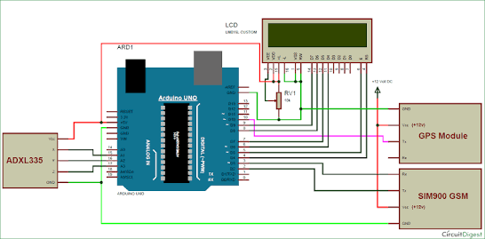

**Fig 2.1 Circuit diagram**

**2.2) Components list**

|  |  |  |
| --- | --- | --- |
| **S.NO** | **COMPONENTS REQUIRED** | **QUANTITY** |
| 1) | Accelerometer adxl 335 | 1 |
| 2) | Sim 300 gprs model | 1 |
| 3) | Antenna | 1 |
| 4) | AT mega8 microcontroller | 1 |
| 5) | Bug strip male | 1 |
| 6) | Bug strip female | 1 |
| 7) | 16 mhz crystal | 1 |
| 8) | 7805 regulator | 1 |
| 9) | 100 µf/16v capacitor | 1 |
| 10) | 10k ohm resistor | 1 |

**Components Description**

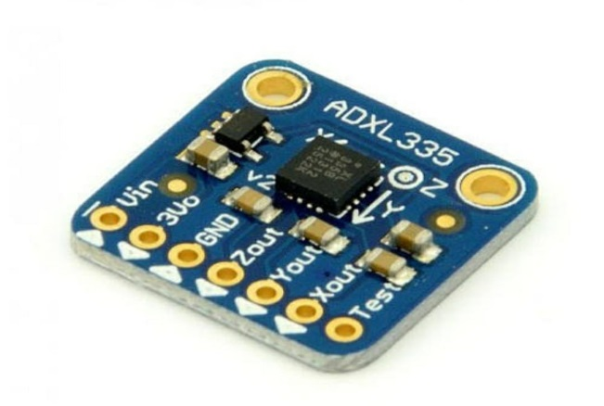**2.21) Accelerometer adxl 335**

* ADXL 335 :-
* Small
* Thin
* Low power
* Complete 3 axis accelerometer
* Signal conditioned voltage outputs **Fig 2.21 Accelerometer**

|  |  |
| --- | --- |
| Features | Specifications |
| * 3-axis sensing | * # of axes: 3 |
| * Small, low-profile package | * Range:+/-3g |
| * Signal-supply operation-(1.8to3.6)v | * Sensitivity:300 Mv/g |
| * 10000 g shock survival | * Output type:Analog |
| * Excellent temperature stability | * Typical Bandwidth(kHz):1.6kHz |
| * 4mm*4mm*1.45mm LFCSP | * Supply Current:350(micro-amp) |

**2.22) Sim 300 gprs model**

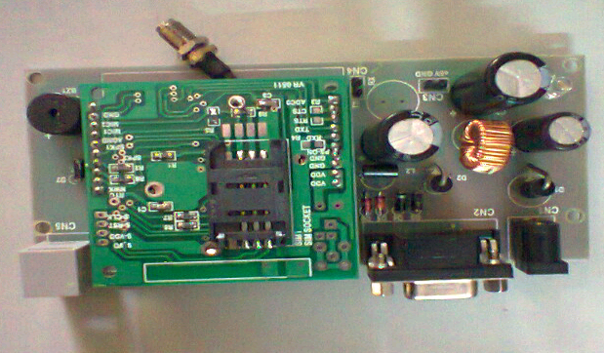

**Fig 2.22 sim 300 gprs model**

SIM 300 may be a GSM modem with an easy serial interface. SIM 300 modem can accept any GSM network operator SIM card and act a bit like a mobile with its own unique phone number. With this module one can send/receive calls. The modem can either be connected to PC interface directly or to any microcontroller. When purchasing purchase the entire board. because it comes with RS232 to TTL converter and Ethernet port. Also do check the module by calling a couple of times when within the shop.

There are two LEDs on the board. One is pow er LED and other is the network LED. When insert your SIM card into the slot and power ON the device the facility LED are going to be turned ON. After few seconds the network LED will start blinking after an interval of three seconds. If this happens it means signal is proper but if it's blinking faster it means there's no network. If your mobile has network then this module should have network at an equivalent location. Make a call and it should ring. Do it a few of times before purchasing from a store.

**2.23) Antenna**

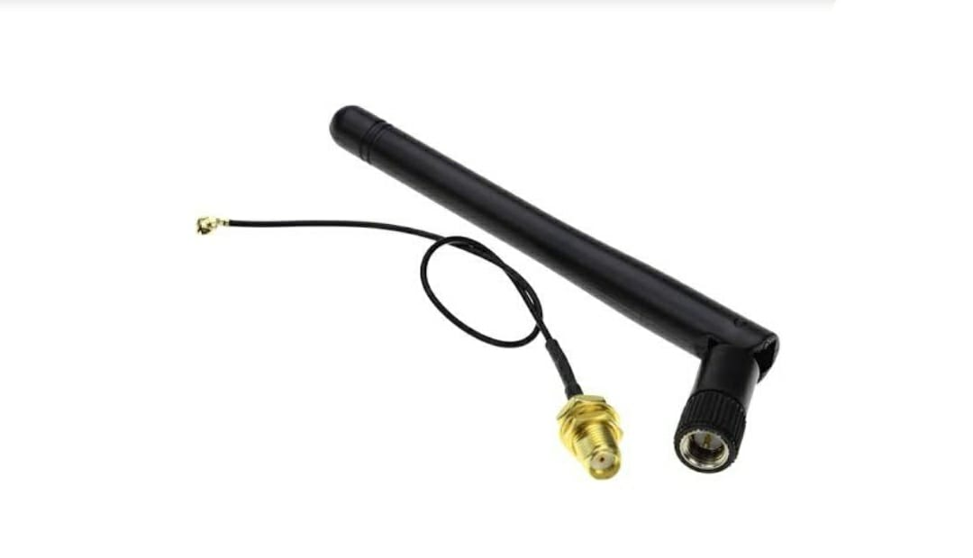

**Fig 2.23 Antenna**

An antenna is that the interface between radio waves propagating through space and electric currents occupation metal conductors, used with a transmitter or receiver. In transmission, a radio transmitter supplied an electric current to the antenna’s terminals, and the antenna radiates the energy from the present as electromagnetic waves (radio waves). In reception, an antenna intercepts a number of the facility of a radio emission so as to supply an electrical current at its terminals that's applied to a receiver to be amplified. Antennas are essential components of all radio equipment.

An antenna is an array of conductors (elements), electrically connected to the receiver or transmitter. Antennas are often designed to transmit and receive radio waves altogether horizontal directions equally (omnidirectional antenna), or preferentially in a particular direction (directional, or high-gain, or “beam” antennas). An antenna may include components not connected to the transmitter, parabolic reflectors, horns, or parasitic elements, which serve to direct the radio waves into a beam or other desired radiation diagram .

**2.24) ATmega8 microcontroller**

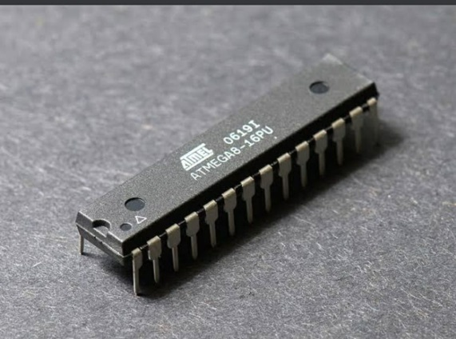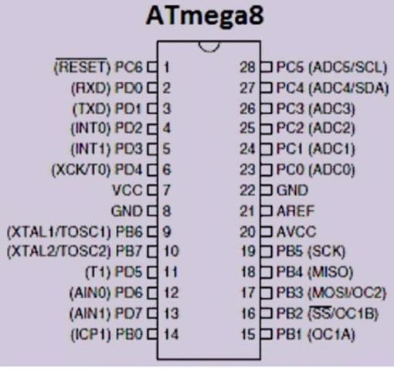

**Fig 2.24 ATmega8 microcontroller**

In 1996, AVR Microcontroller was produced by the “Atmel Corporation”. The

Microcontroller includes the Hardvard architecture that works rapidly RISC. The feature of

the microcontroller include different features compared with other like sleep modes-6,

inbuilt ADC (Analog to Digital Convertor), internal oscillator and serial data communication,

performs the instruction in a single execution cycle. These Microcontrollers were very fast

and they utilize low power to figure in several power saving modes. There are different

configurations of AVR microcontrollers are available to perform various operations like 8-bit,

16-bit and 32-bit.

**2.25) Male and Female Bug Strip**

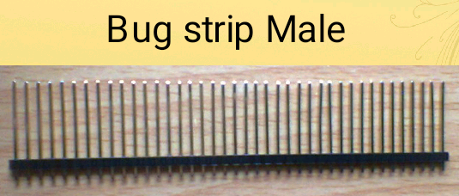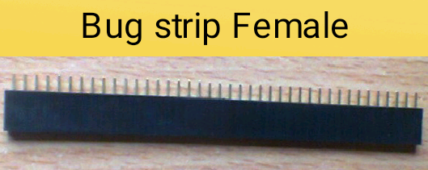

**Fig 2.25 male and female bug strips**

A pin header (often abbreviated as PH or simply header) is a form of electrical connector. It consists of one or more rows of male pins typically spaced 2.54 millimetres (0.1 in) apart, but common sizes also include 5.08 millimetres (0.2 in), 5.00 millimetres (0.197 in ), 3.96 millimetres (0.156 in), 2.00 millimetres (0.079 in), 1.27 millimetres (0.05 in) and 1.00 millimetres (0.04 in). The distance between pins is commonly referred as pitch in the electronic community.

**2.26) 7805 regulator**

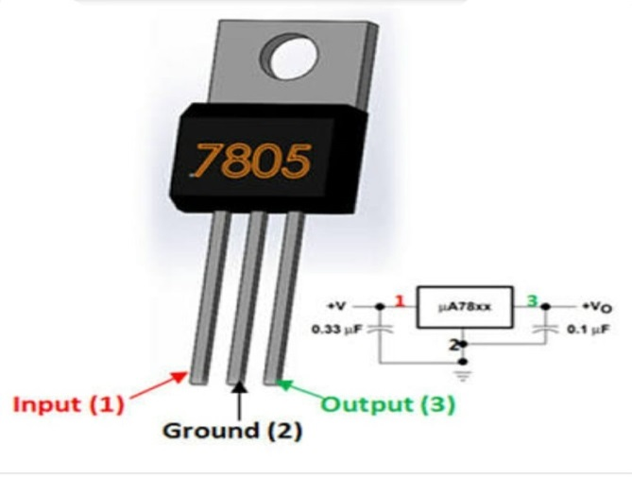

**Fig 2.26 Regulator 7805**

All voltage sources cannot able to give fixed output due to fluctuations in the circuit. For getting constants and study output, the voltage regulator is implemented. The integrate circuits which are used for the regulation of voltage are termed as voltage regulator ICs. Here, we can discuss the IC 7805.

The voltage regulator IC7805 is actually a member of 78XX series of voltage regulator ICs.

It is a fixed linear voltage regulator. The XX present in 78XX represents the value of fixed output voltage that particular IC provides. For 7805 IC, it is +5V DC regulator power supply. This regulator IC also adds a provision for heat sink. The input voltage to tis voltage regulator can be up to 35 V. And this IC can give a constant 5V for any value of input less than or equal to 35 V which is threshold limit.

PIN 1-INPUT

The function of this pin is to give the input voltage. It should be in the range of 7V to 35V. We apply an unregulated voltage to this pin for regulation. For 7.2 Volt input, the PIN achieves its maximum efficiency.

PIN 2-GROUND

We connect the ground to this pin. For output and input, this pin is equally neutrally (0 V).

PIN 3-OUTPUT

This pin is used to take the regulated output.

**2.27) Capacitor 100 µF/16 V**

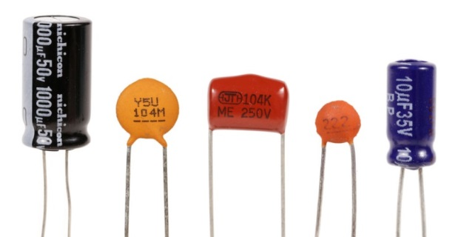 **Fig 2.27 Capacitors**

1. Conducts alternating current (AC)

2. Blocks direct current (DC)

3. To store energy

4. To filter signals according to their frequency.

**2.28) 16 MHZs Crystal**

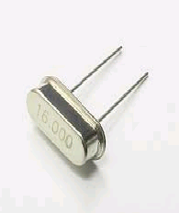

**Fig 2.28 16MHz crystal**

1. Electronic oscillator circuit
2. Uses the mechanical resonance of a vibrating crystal of piezoelectric material
3. Creates an electrical signal with a very precise frequency
4. Quartz crystals are used as piezoelectric resonator

**2.29) Resistors**

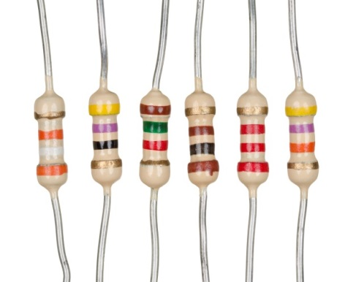

**Fig 2.29 Resistors**

1. Passive two-terminal electrical component
2. Resists the flow of current

**2.30) 12v Rechargeable battery**



**Fig 2.10 Rechargeable battery 12v**

Devices which use rechargeable batteries include automobile starters, portable consumer devises, light vehicles (such as motorized wheelchairs, golf carts, electric bicycles, and electric forklifts), tools, uninterruptible power supplies, and battery storage power stations.

**CHAPTER-3**

**Hardware implementation**

**3.1) Working of project**

The fall detection pendant is consistently detecting your movements. The fall Detection pendant contains tiny sensors that can detect changes in motion, as well as changes height of the pendant. These sensors are sampled up to 100 times per second, and they are monitored in real –time to detect tiny changes in motion that you simply may make.

The data obtained from the sensors gives us specific information about the user’s motion, such as your gravitational forces (or “G forces”) and moving velocity. This information is analysed in real-time by LifeFone’s Fall Detection algorithm to determine if the person wearing the autumn detection pendant has experienced a motion pattern that indicates a fall.

If the system detects a fall, an alarm will sound. You will have time to cancel it if you haven’t actually fallen. The system waits for 20-30seconds to see for normal movement before announcing a pending fall alarm. The base station will then wait and 20 additional seconds to allow you to manually cancel a fall alarm. If you’ve activated the alarm by accident, you can press and hold the button on your fall detection pendant button on your fall detection pendant button for five seconds to cancel it. It’s important to cancel a warning , because if we don’t hear from you, the alert goes to LifeFone’s emergency response centre, just as it would once you press your emergency button for help.

There comes a point when each of us comes to the realization we need assistance. Between work, dealing with our families and trying to find a little personal time, it’s difficult to take on more tasks and responsibilities. If the need arises to begin caring for an aging loved one, there are numerous considerations. The ideal situation for all is if the individual is able to stay at home providing the persons health and mobility is adequate. One important step toward aging in place is to equip the home with a medical alert system. This system provides the senior with independent living while allowing the caregiver some time for herself.

Other factors to consider when helping your loved senior age in place are below:

* Basic shopping and running errands can become troublesome for seniors. Many no

longer drive and finding alternative ways for your loved one to get around can be

time consuming. Ask family members to pitch in and help transport your loved one

to medical appointments, shopping, and personal errands such as the hairdresser.

There are also convenient businesses that deliver thing such as groceries and

medication if desired.

* Chores associated with owning a home can become difficult for aging seniors. While relatives can help pitch in, simple things like cleaning and vacuuming may be best addressed by hiring someone. Also, constant maintenance of the home such as lighting, roofs, shovelling snow, ranking leaves, plumbing and other wear and tear items around the home are topics and tasks to be discussed.It is important to remember that aging in place can become lonely and its important to talk with and visit your loved one often. Having dinner once a week when the caregiver is not there or calling to say hello is a great way to encourage your senior to continue to work hard at whatever they are doing and to enjoy their life. Obviously, every circumstance is unique and requires its own approach but working together with your loved senior will allow them to stay in their home and age independently.

**3.32) System Design**

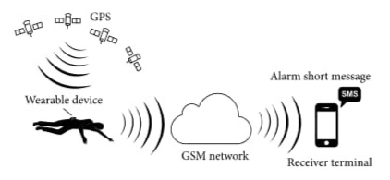

**Fig 3.32 system design**

The architecture of the developed system is described in below Figure. A wearable device is placed on human waist. The system can detect the elderly falling by acceleration analysis. Then it'll get the elderly geographic position and send fall alarm short message to caregivers. Therefore the elderly who has fallen can get timely help to attenuate the negative influence.

**3.33) Applications**

The application was developed trying to satisfy the below requirements that the Human Fall

detection problem presents.

1. Detect the event of a Human Fall with a high accuracy

2. Report the Fall ASAP to the host. The requirement is met. But no application has

been created, therefore the customer would wish to make its own GUI and interface it with

the service that the custom requirements need. (i.e., internet access for e-mail

reporting, phone network access for 911 reporting, etc.).

3. Store the external memory the after fall conditions. The application saves all the

current “human state” and “energy expenditures” data before and after the fall.

The data is downloadable through RS232, when starting the device in dumping mode.

**CHAPTER-4**

**4.1) BLOCK DIAGRAM**

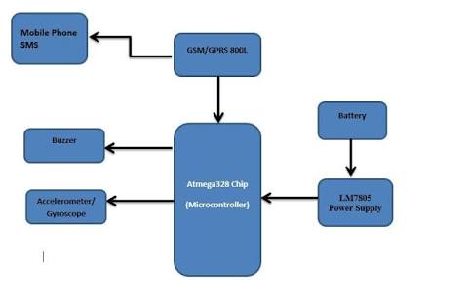

**Fig 4.1 Block diagram**

**CHAPTER-5**

**Hardware picture, Theory**

**5.1) Hardware picture**

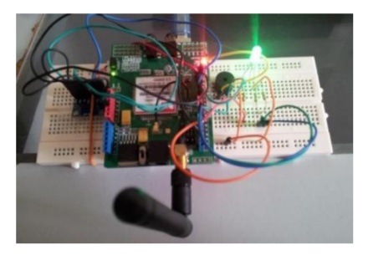

**Fig 5.1 Hardware picture**

**5.2) Theory**

Choice of recognition feature has decisive significance to successful fall detection, Information like linear movements (e.g., displacement, velocity, and acceleration) and angular movements (e.g., angle, angular velocity, and angular acceleration) could be obtained directly or indirectly. Beside these, frequency domain parameters could be extracted from basic sensor measurements by techniques like FFT and wavelet. For single triaxial accelerometer application, accelerations and derived angular parameters could be used as recognition features.

Fall detection algorithm design is predicated on the selection of recognition features. According to the recognize feature, fall detection algorithms are classified as threshold based and machine learning based. For threshold based method, threshold of recognition feature is about by the designer before application which makes the algorithm have rapid response and fewer resource consumption. But the selection of threshold needs both rigorous schemes and adequate experiments. For machine learning based design, the classification of fall and normal activities is available with the assistance of the technologies such as support vector machine (SVM) and neural network. Machine learning assistance may enhance system robustness to some extent, but its algorithm design is usually high computing resource consumed which limits its application in wearable device. As the compact wearable device requires low power consumption and as single triaxial accelerometer could provide effective information, threshold based fall detection algorithm are going to be used.

**CHAPTER-6**

**RESULT**

This review identified 57 projects that used wearable systems and 35 projects using non-wearable systems, regardless of evaluation technique. Non-wearable systems included cameras, motion sensors, microphones and floor sensors. There were no studies of non-wearable devices that used older adults as subjects in either a lab or a real world setting. In general, older adults appear to be interested in using such devices althoudh they express concerns over privacy and understanding exactly what the device is doing at specific times.

**CHAPTER-7**

**Advantages and Disadvantes, Conclusion**

**7.1) Advantages**

1. Automated fall detections using sensors

2. Even slight manual intervention of pressing of a button is not required from elderly &

paralytic persons

3. Immediate notification of fall detected to local

4. Physician & one close relative of patient

5. Cheap & available in affordable rates

6. Sensors are reliable & damage proof even when used by heavy bodied patients

**7.2) Disadvantages**

1. False alarms if generated could be frustrating for seniors.

2. In case of bad network coverage in mobiles SMS alerts could be delayed.

3. Fall SMS alerts cannot be used with CDMA SIM cards.

**7.3) Conclusion**

This paper presented the planning and implementation of a fall detection sensor system that uses the four characteristics (Weightlessness, Impact, Motionless, and Initial status) the criteria for a fall detection and computation. This system is useful for the elderly people who live alone at home to ensure their personal safety, in which the system will inform the contact person after a fall incident happened. Ambulance department will also be contacted to arrive at the falling location and give medical treatment for the elderly as soon as possible. Fall detection may be necessary for your mother or father’s situation-even with the potential high rate of false alarms

**CHAPTER-8**

**Reference**

1. Lord SR,Sherrington c, Menz HB. Falls in older people: risk factors and strategies for prevention. Cambridge ,U.K: Cambridge Univ. Press.
2. Tinetti ME. Clinical practice. Preventing falls in elderly persons. N Engl J Med.
3. Stevens JA, Mack KA, Paulozzi LJ, Ballesteros MF. Self-Reported falls and fall related injuries among persons aged>65 years.
4. Hausdorff JM, Rios DA, Edelberg HK. Gait variability and fall risk in community-living older adults: a 1-year prospective study. Arch Phys Med Rehabil.
5. Tinetti ME. Prevention of falls and fall injuries in elderly persons: a research agendHK. Gait variability and fall risk in community-living older adults: a 1-year prospective study. Arch Phys Med Rehabil.
6. Tinetti ME. Prevention of falls and fall injuries in elderly persons: a research agenda.
7. Center for disease control and prevention. Falls among older adults: an overview.